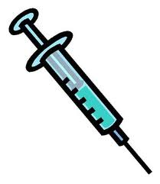

***SCHOOL DISTRICT OF CRANDON***

***IMMUNIZATION RECORDS PERMISSION 2018-2019***

Date ______________________ Teacher ______________________________

Student Name ____________________________________________________

I give the staff of the School District of Crandon permission to share immunization records with local health officials (county & tribal as applicable) and exchange immunization information with the Wisconsin Immunization Registry.

______________________________________________________

Parent/Guardian Signature

***SCHOOL DISTRICT OF CRANDON***

***TYLENOL PERMISSION 2018-2019***

Date ______________________ Teacher ______________________________

Student Name ____________________________________________________

I give the staff of the School District of Crandon permission to give my child a Tylenol when necessary during the 2018-2019 school year.

______________________________________________________

Parent/Guardian Signature

***SCHOOL DISTRICT OF CRANDON***

***MEDIA RELEASE***

***PERMISSION 2018-2019***

I grant permission for my student, ____________________________________, to be published in the newspaper and other form of media during the 2018-2019 school year.

______________________________________________________

Parent/Guardian Signature